Introduction to S32K144, S32DS, FreeMASTER and MBDT

Contents

• Get to Know S32K144 EVB

• Setup of S32K144 EVB

• Creating a new S32DS project for S32K144

• S32DS Debug basics

• Create a P&E debug configuration

• Model Based Control Toolbox (MBDT)

• Appendix A: Locating the host ID

• Appendix B: Introduction to OpenSDA

S32K144-EVB

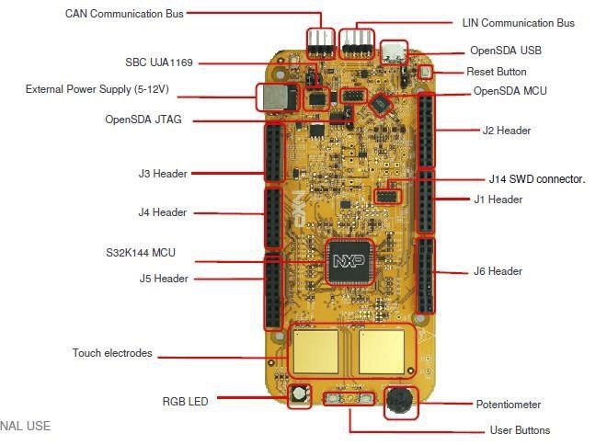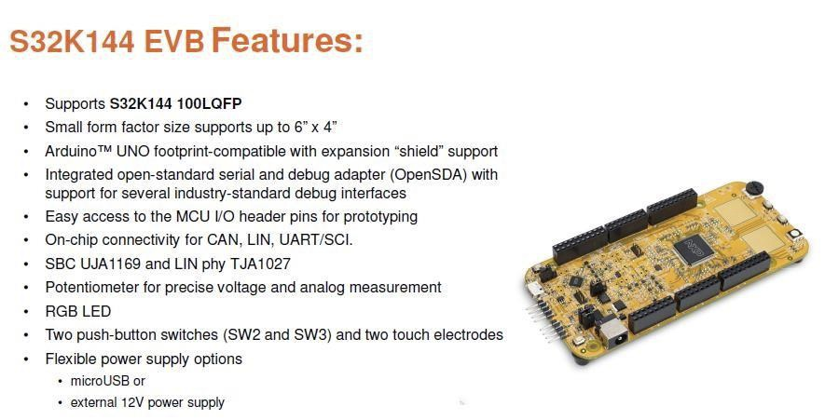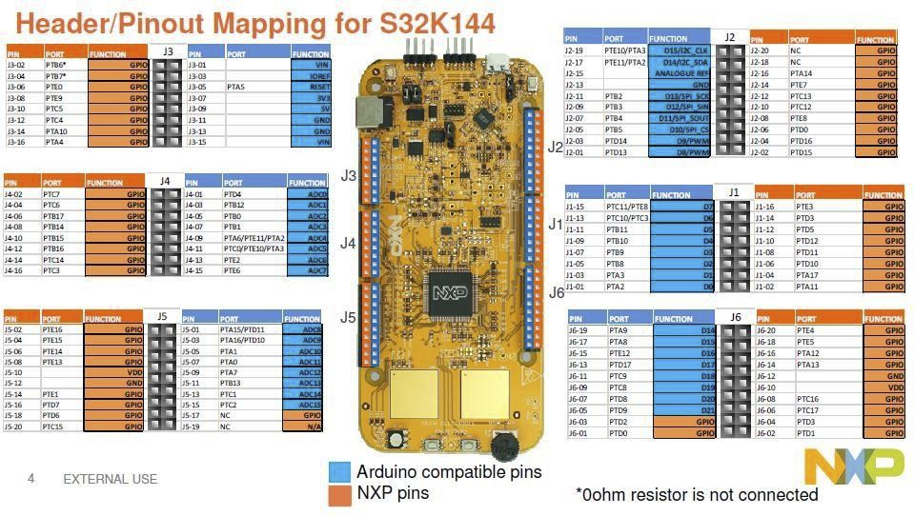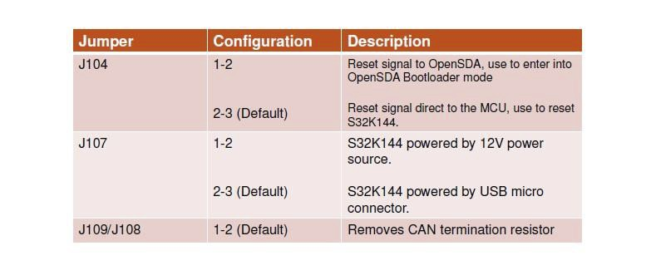

Jumper Settings

Please do not change the jumpers at the present time.

HMI mapping

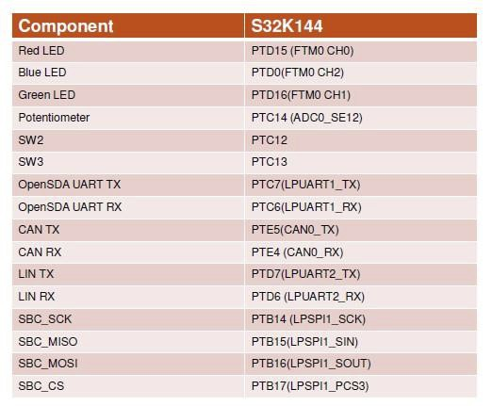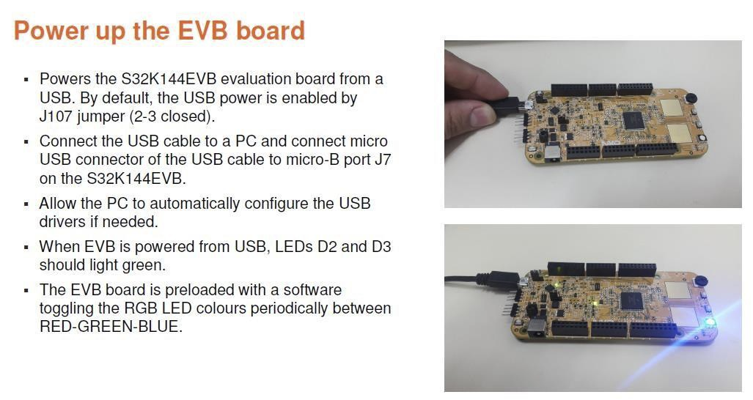

• When powered through USB, LEDs D2 and D3 should light green

• Once the board is recognized, it should appear as a mass storage device   
in your PC with the name EVB-S32K144.

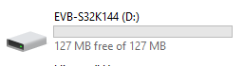

FreeMASTER

Install the FreeMASTER tool

• Download and install the FreeMASTER PC application   
[www.nxp.com/FreeMASTER.](http://www.nxp.com/FreeMASTER)

• Open the FreeMASTER application on your PC. You should see Welcome   
page as given in next page.

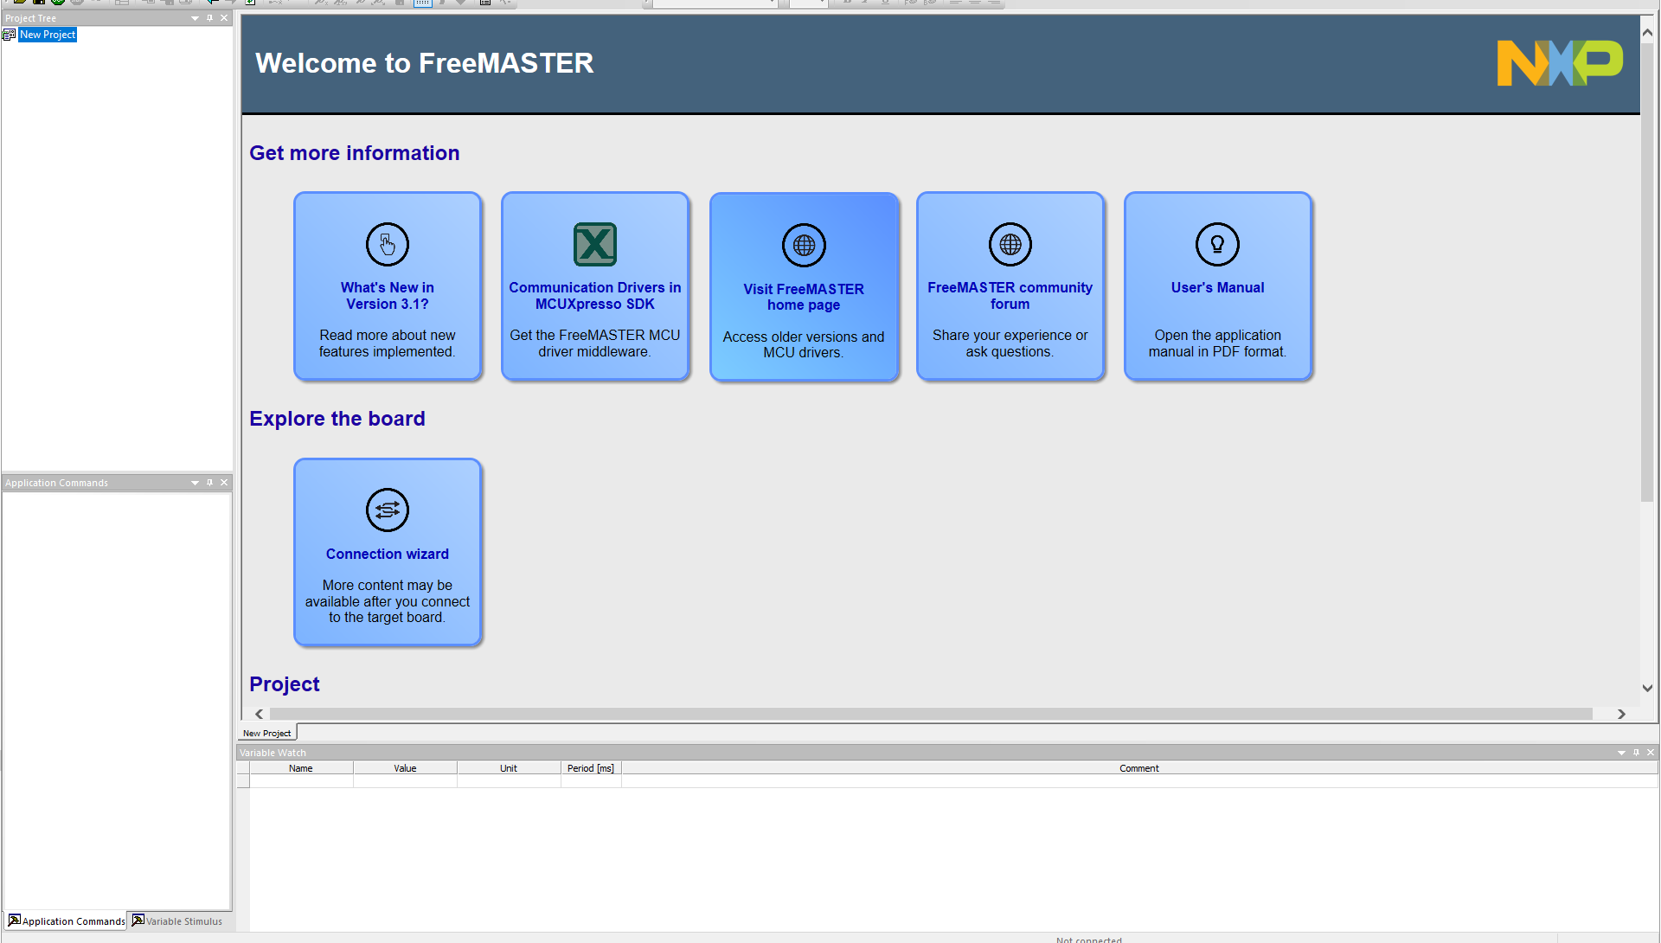

Setup of serial connection in the FreeMASTER tool

• Go to Project > Options > Comm.

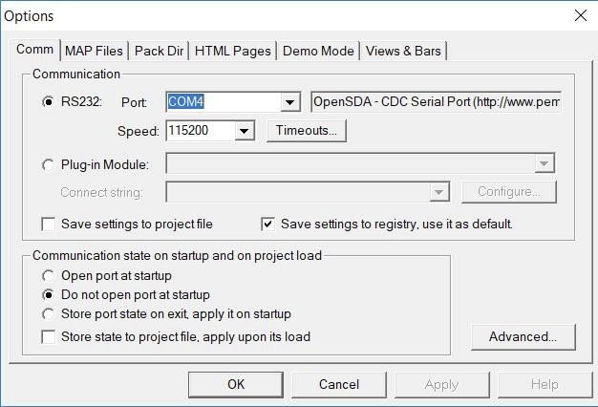

Setup communication port to the one available in the drop down.

“OpenSDA” and speed to 115200.

You may also use the following setup for serial connection in the

FreeMASTER tool.

Another way to Setup the serial connection in the FreeMASTER tool

• Select Tools > Connection Wizard > Next.

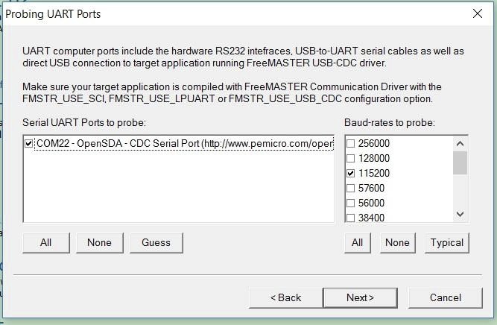

• Select “use direct connection to onboard USB port”͘, Next

• Select OpenSDA COM port and 115200 baud rate > Next > Finish.

S32 Design Studio Installation and Creating a Project.

I . Download and Install S32DS

• Click on the following link:

[https://www.nxp.com/support/developer-resources/run-](https://www.nxp.com/support/developer-resources/run-time-software/s32-design-studio-ide/s32-design-studio-ide-for-arm-based-mcus:S32DS-ARM)

[timesoftware/s32-design-studio-ide/s32-design-studio-ide-for-arm-](https://www.nxp.com/support/developer-resources/run-time-software/s32-design-studio-ide/s32-design-studio-ide-for-arm-based-mcus:S32DS-ARM)  
[basedmcus:S32DS-ARM](https://www.nxp.com/support/developer-resources/run-time-software/s32-design-studio-ide/s32-design-studio-ide-for-arm-based-mcus:S32DS-ARM)

• Select download

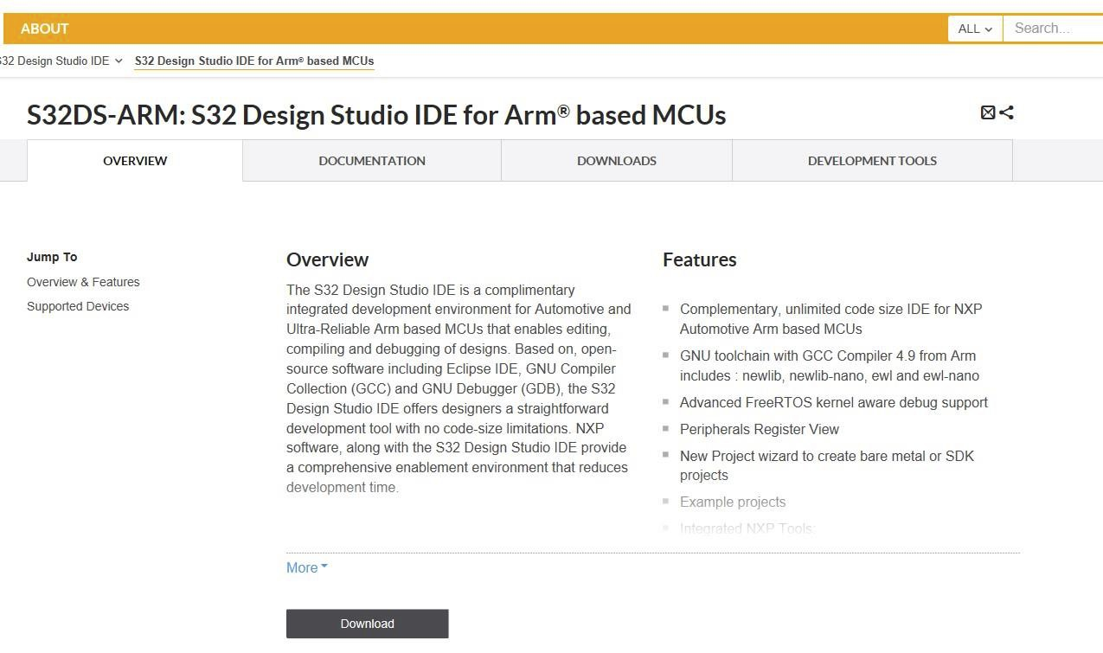

• Download S32 Design Studio for Arm 2.2:

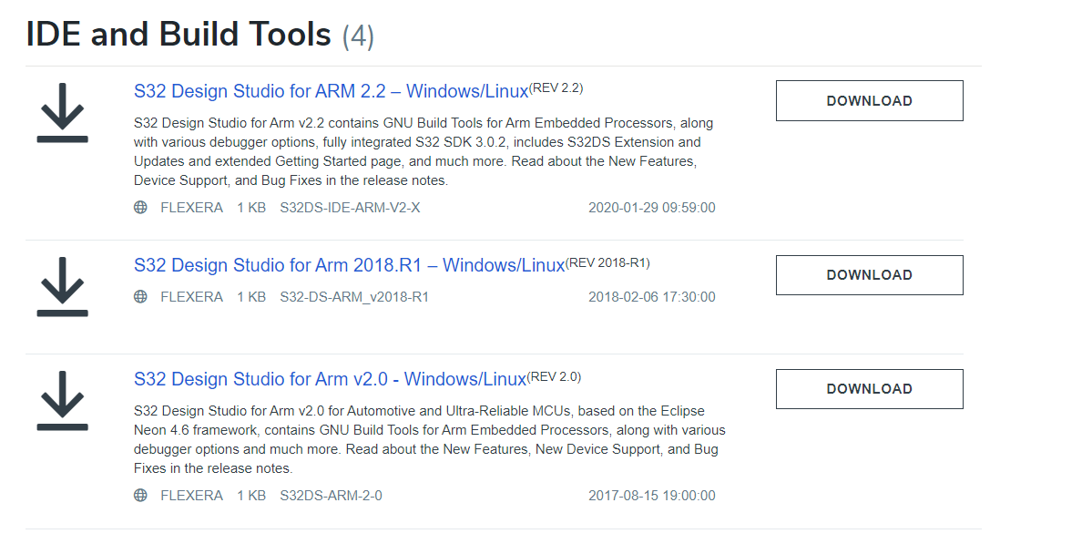

• You will be prompted to sign in. Sign in/ Sign Up

Please note that you need to generate the license key for installing the   
software by clicking on the “License Keys” tab. Use the “activation code” to complete your installation.

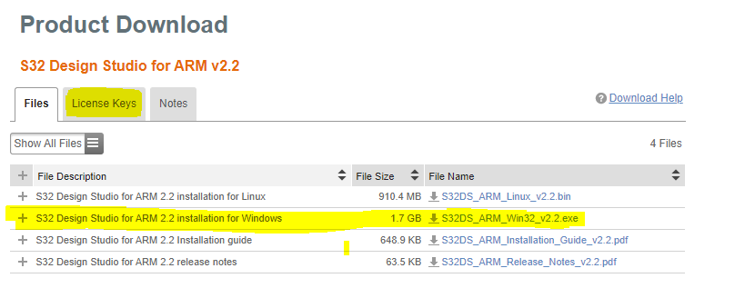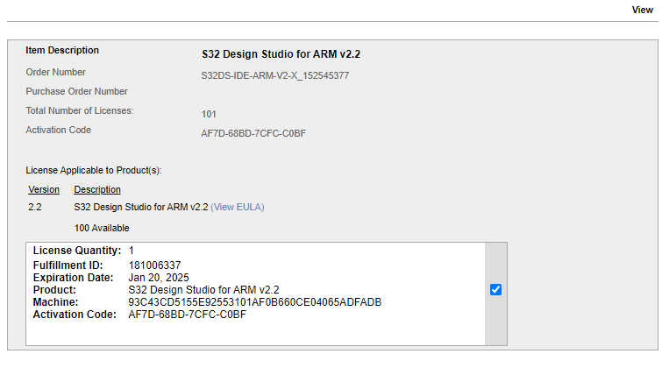

**Complete the installation of S32 DS.**

II. Create a S32 SDK project using the New S32DS Project wizard

• Start -> programs -> Click on “S32 Design Studio” icon͘

• Select workspace:

− Choose default or specify new one

− Suggestion: Uncheck the box “Use this as the default and do not ask again”   
− Click OK

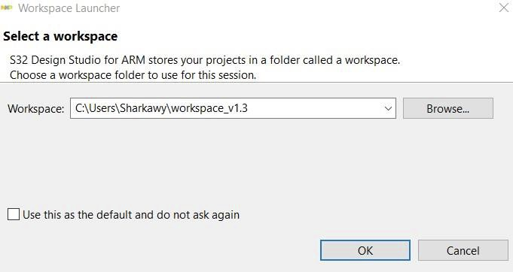

Create a S32 SDK project using the New S32DS Project wizard.

• Select File > New > Application Project, from the IDE menu bar.

• Specify a name for the new project. For example, enter the project name as Project1.

• Select the Processor S32K144 from Processors-> Family S32K1xx section.

• Click Next.

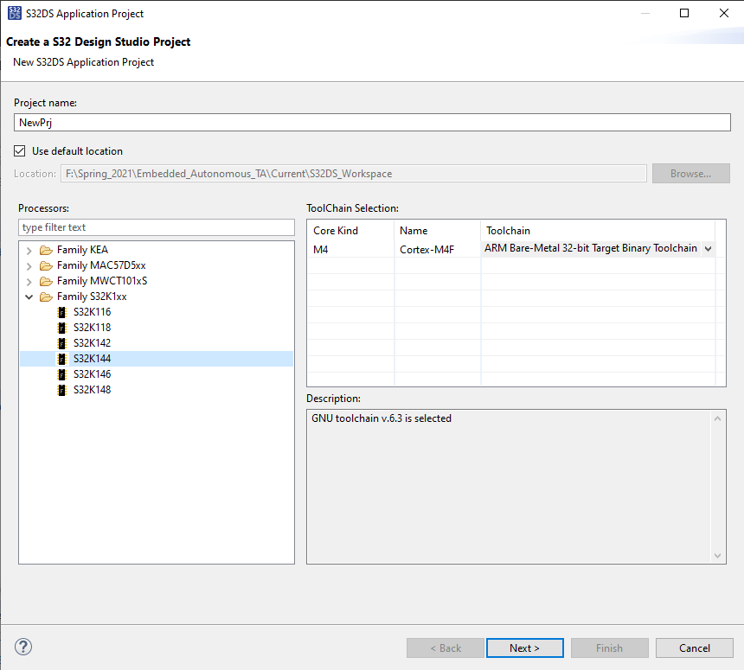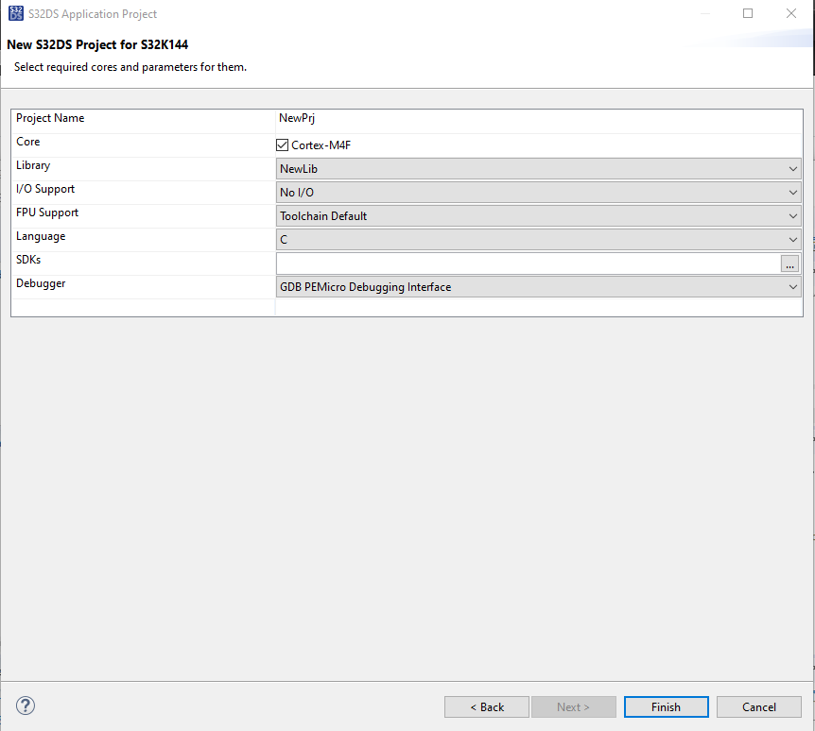

• Click on button to select available SDKs.

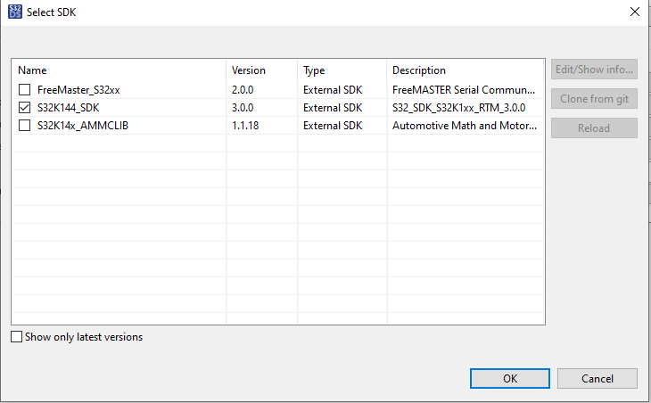

* Click OK.
* Click Finish.

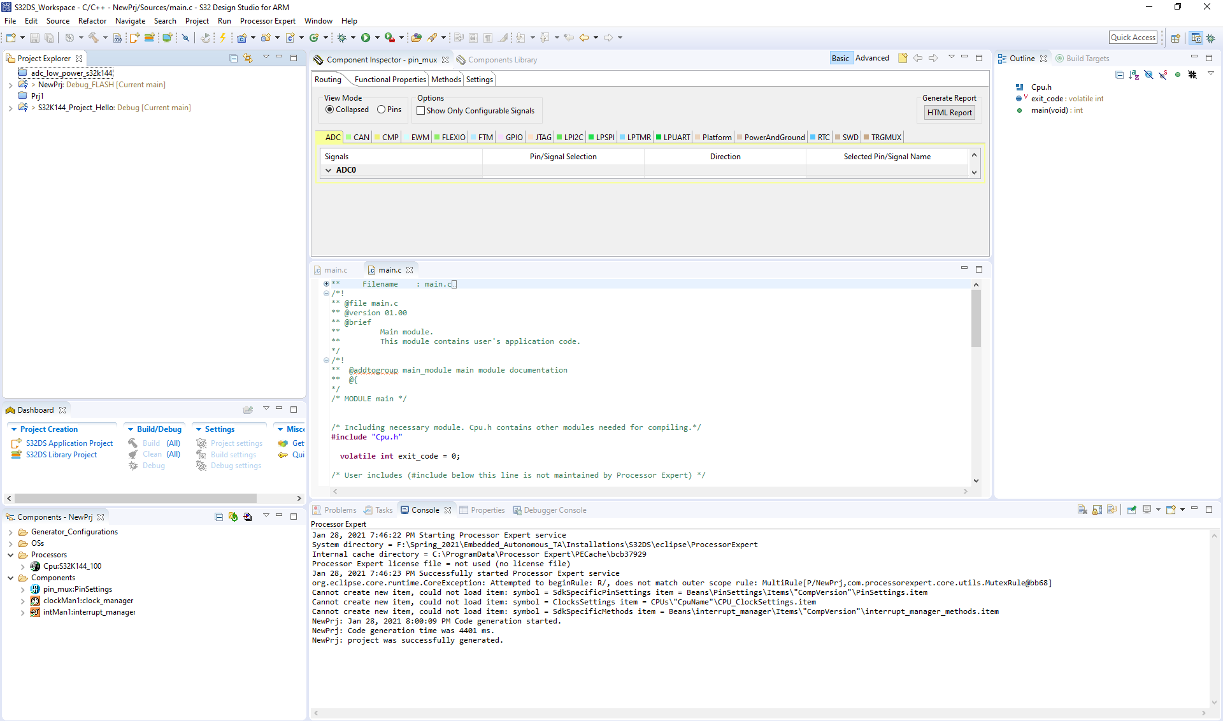

* Processor Expert components can be observed at the Components View.
* Start project build by clicking on Build Icon or invoking right click menu on project and selecting Build Project.



* This build should execute without any errors.

III. Importing an existing project

• Select File > Import, from the IDE menu.

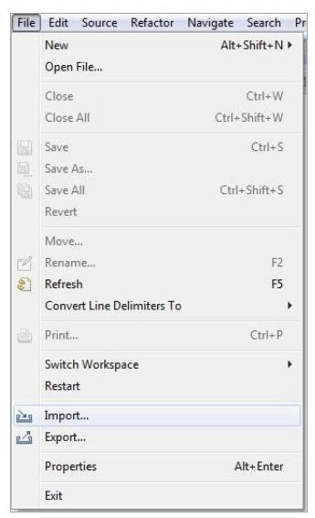

• Expand General tree and Select Existing Projects into Workspace

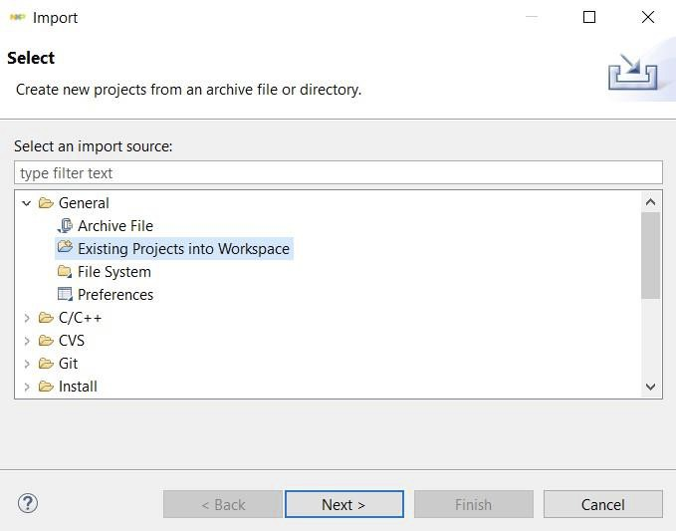

• Click Next.

• Click Browse and select the example folder from SDK installation directory to search for the

“ADC_LOW_POWER” Eclipse project (For example, the “ADC_LOW_POWER” folder can be located at:

{S32 DS Installation Location}\ S32DS\ software\ S32SDK_S32K1xx_RTM_3.0.0\ examples\ S32K144\ demo_apps\ adc_low_power.

C:\NXP\S32DS_ARM_v1.3\S32DS\software\S32SDK_S32K1xx_RTM_3.0.0\ examples\S32K144\ demo_apps\ adc_low_power).

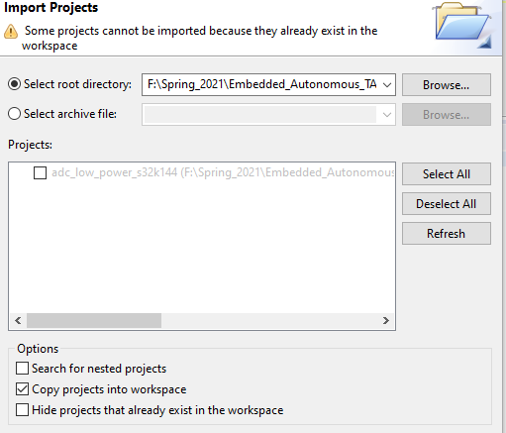

* It is useful that you copy project to your workspace by checking the “copy project into workspace”. This will create a copy of the project in your workspace and will not affect the original after changes are made.
* Click Finish to load the project.

Using New Project from Example

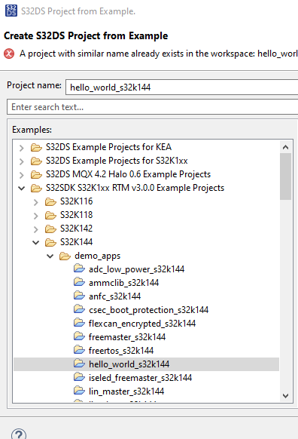

* Select

File -> New ->   
S32DS Project from Example -> S32DS S32K1xx RTM v3.00 Example Projects ->   
S32K144 -> hello_world_s32k144.

* This is an LED blink project.
* The project will be copied in your workspace.
* Build the project.
* The error generated is due to missing files of cpu.h, clockman1.h, pin_mux.h, These are produced by the components “**Processor expert code”** generators.
* Click on the Components window
* Select **Generate Processor Expert Code Icon** to generate those header files to support your project.

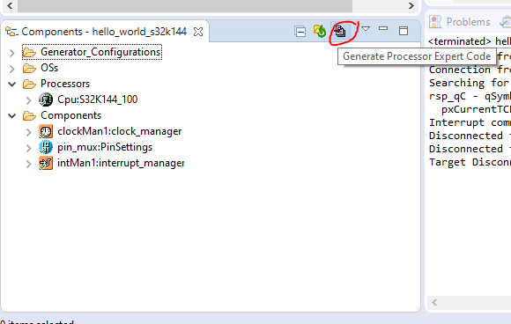

* Then Build again. The errors should be solved now.

Debugging Projects

• Select the project.



• Click on select Debug Configurations.

Alternatively, you can select Run > Debug Configurations from the IDE   
menu bar.

(Please be sure that the S32K144 board is connected to your laptop)

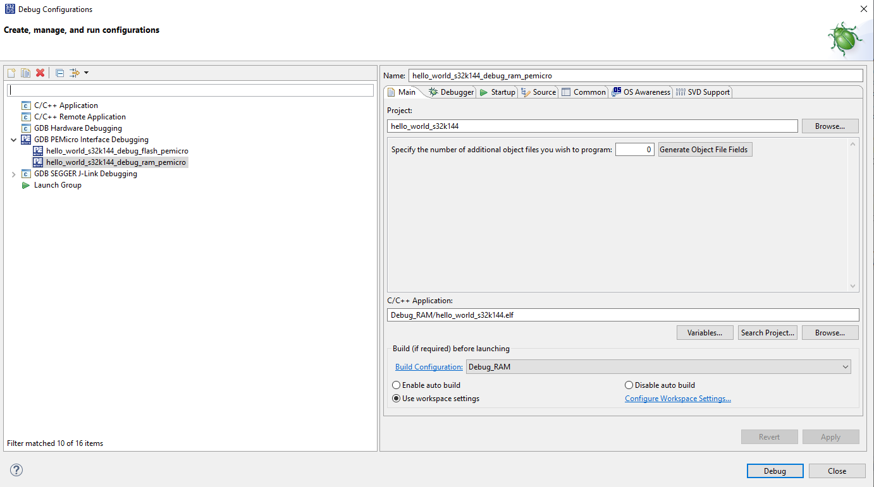

• Verify the values in the Debug tab with the highlighted values in the Image and then Click Debug.

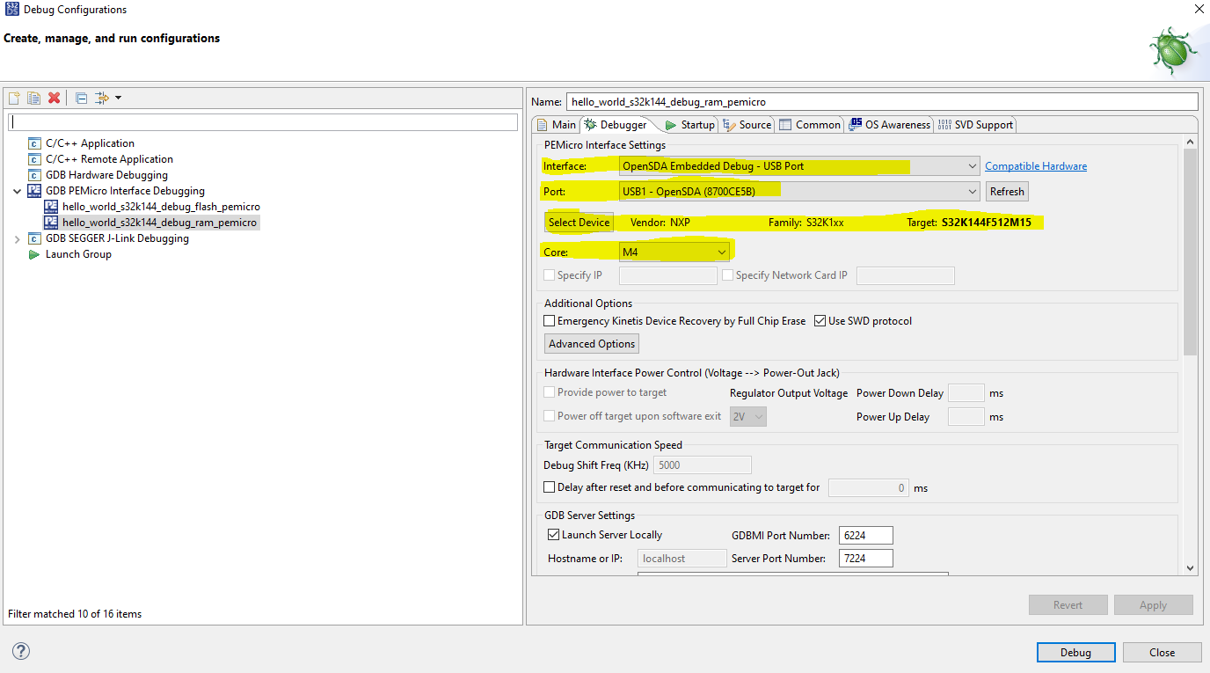

• This will compile and download the code to your S32K board and the RGB LED on the board will be blinking as your code executes on your evaluation board.

Model Based Design Toolbox (MBDT)

Installing Model Based Design Toolbox (MBDT)

Go to [www.nxp.com/mctoolbox](http://www.nxp.com/mctoolbox)

1. Click on “Download”͘
2. Login with your NXP login.
3. Select “Previous Tab”. Check next page for reference.
4. Select version 4.0.0: Model-Based Design Toolbox for S32K14x Automotive Microprocessors Family.
5. Read and Accept the terms & conditions.

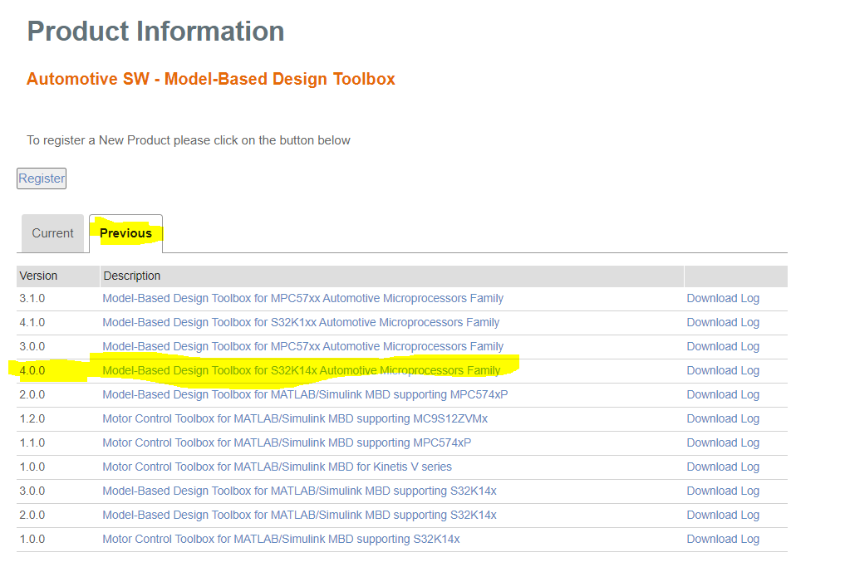

1. Download the two Highlighted MATLAB toolboxes.

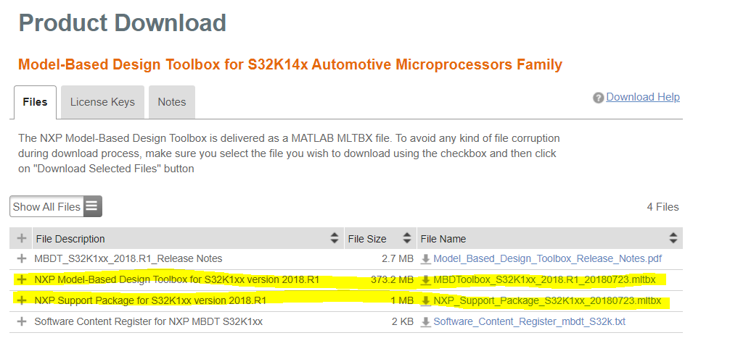

Note: While downloading these your PC will tend to change the extension to “*.zip”; please correct them by making it “.mltbx”.

1. As downloading is in progress, go to the **Licence Keys** tab in the above image and we will generate license from there.
2. If Windows OS, Open command prompt and type the following.

vol C:

This will give you, your PC’s **Disk Serial Number** you can use this to generate the license. After license is generated press **Save All** to download the license and save the file as “license.lic” to store them into your PC.

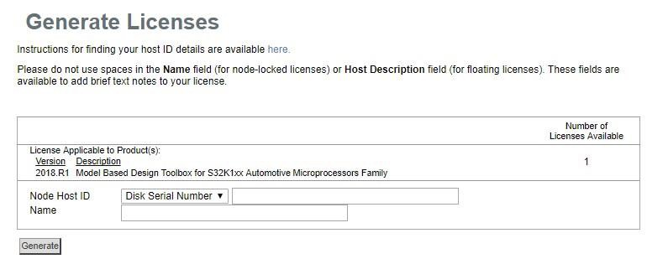

1. Open MATLAB 2018b and drag and drop this downloaded **NXP_Support_Package_S32K1xx_20180723.mltbx** to the command window. This will help you in a step-by-step guide to install the downloaded toolboxes.
2. Open Addons dropdown options -> Manage Add-ons.

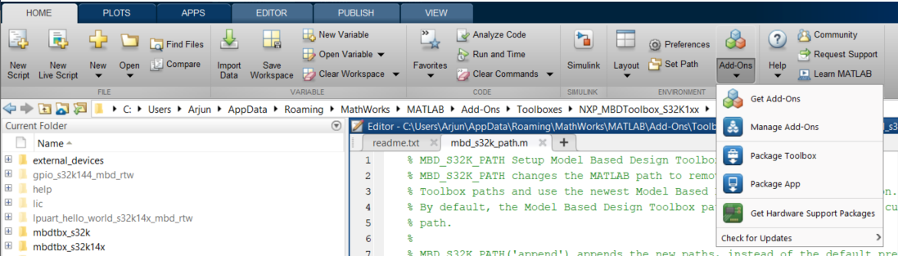

1. Select NXP Support package s32k1xx -> open folder as in the below figure:

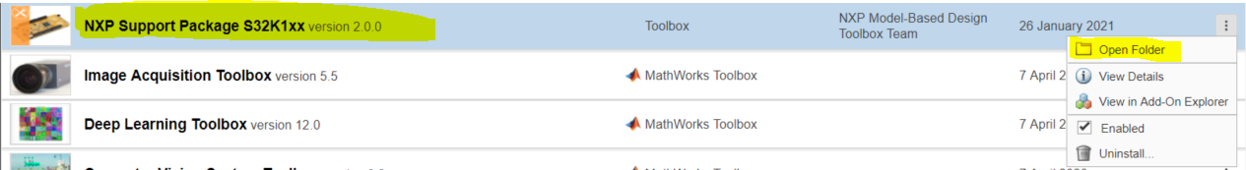

1. Run the NXP_Support_Package_S32K1xx.m as in the following figure:

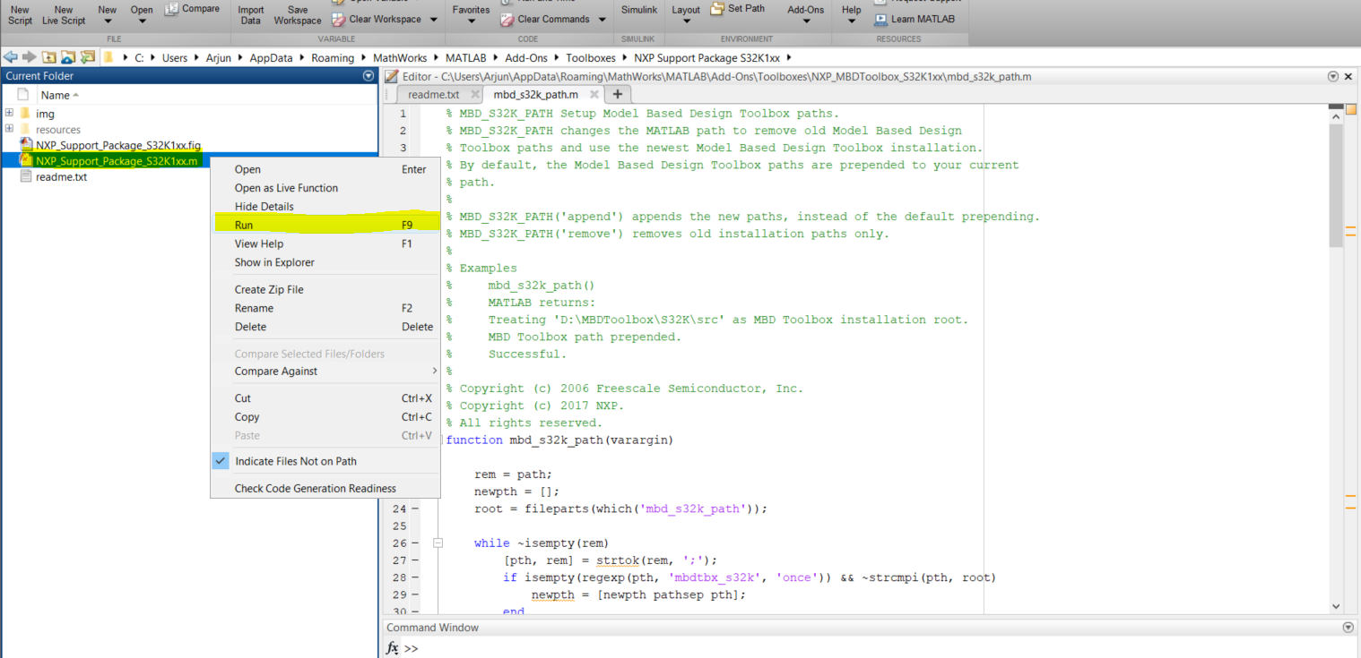

1. Complete All the highlighted steps by clicking on the buttons in the pop up that comes from the previous step. Please refer following image.

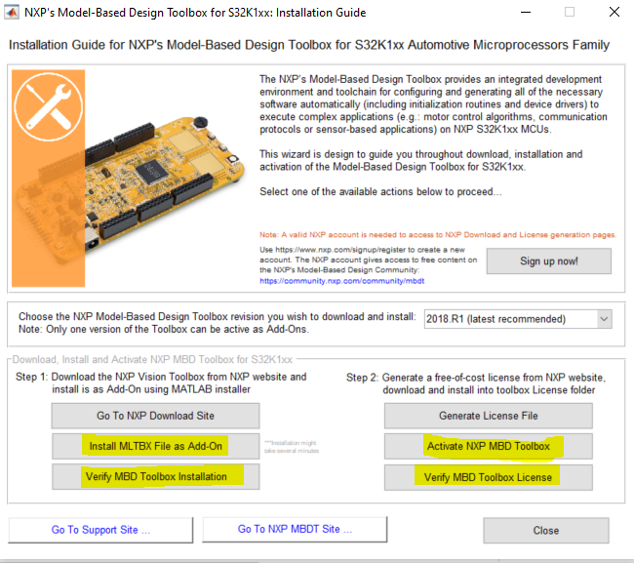

1. The MLTBX file is the second file that was downloaded, i.e, “M**BDToolbox_S32K1xx_2018.R1_20180723.mltbx”**

Setting the Path for MBDT in MATLAB

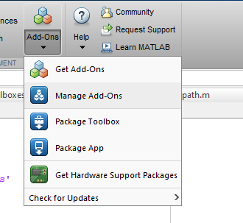

* Setting the Path for Model-Based Design Toolbox for MALAB to recognize the Model-Based Design Toolbox, the path needs to be setup in the MATLAB   
   environment.
* Start MATLAB 2018b. Go to Addon -> Manage Addons.
* Select the options for NXP_MBDToolbox_S321xx, and click Open Folder
* Run the “mbd_s32k_path.m” path script. Right Click -> Run.

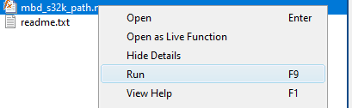

* After running it successfully, the following message should be seen in   
  the command window.

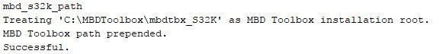

Run Models: Examples Library

• The Model Based Design Toolbox for S32K14x comes with an Examples Library   
 collection that let you test different MCU on-chip modules and run complex   
 applications.

• The Examples Library mbd_s32k_examples͘mdl can be opened from “{Model   
 Based Design Install Directory}\S32_Examples” folder͘

• Shown Below:

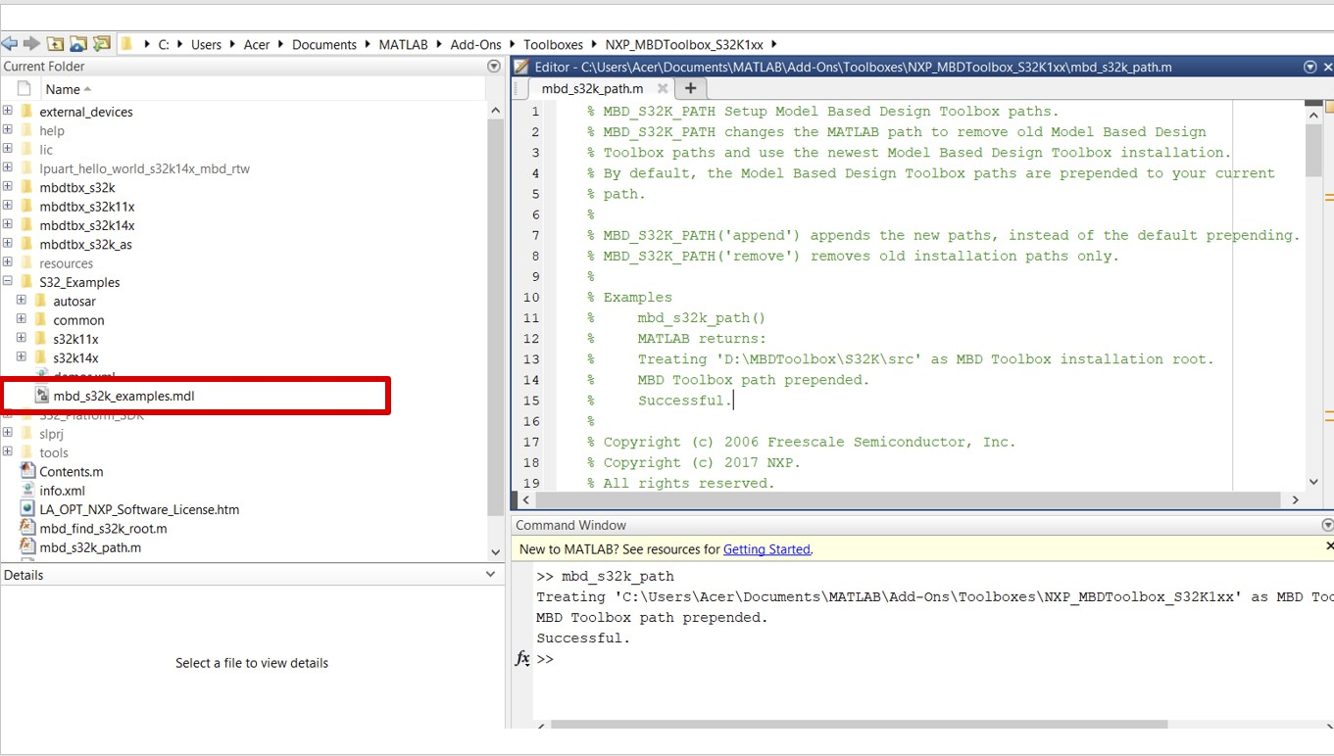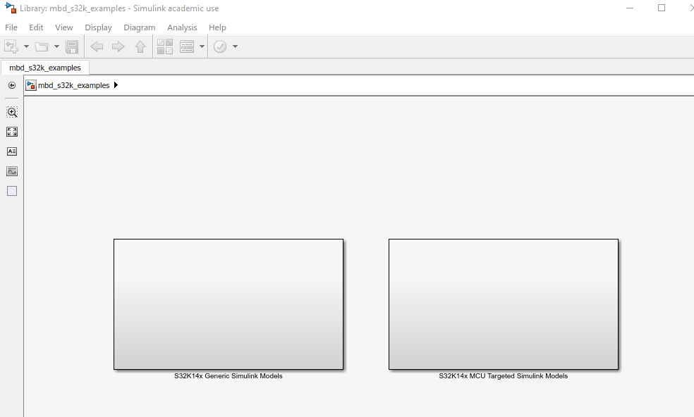

* Each category contains multiple examples that showcase different   
  Model Based Design Toolbox example and blocks.

(Skip Until There’s Error) You may need to add a New System variable

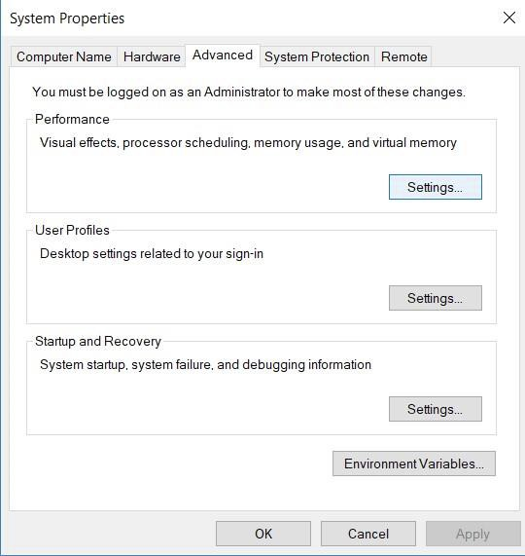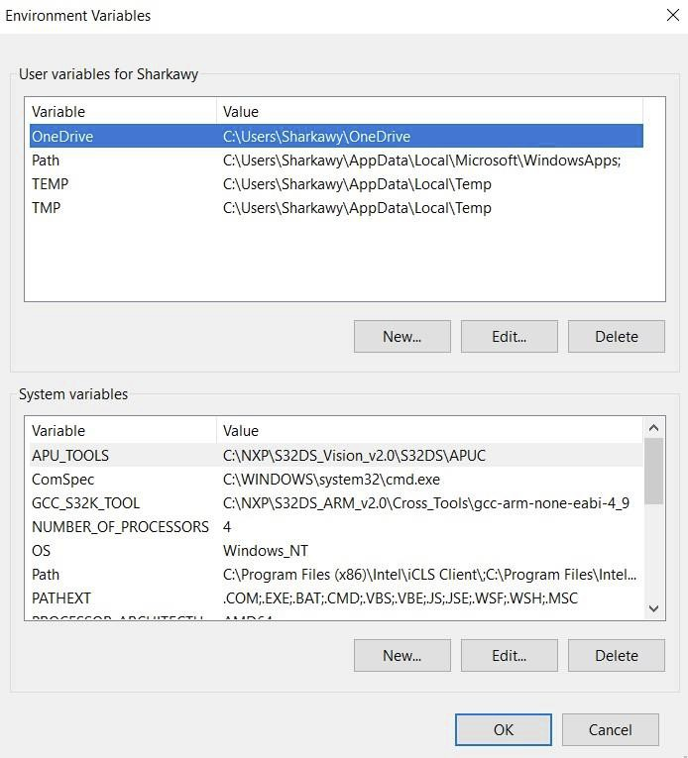

• Add the New System Variable and click OK.

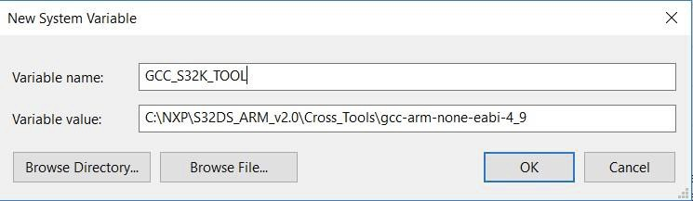

Hello World Example

• Check that the virtual COM port is created and visible in Control   
Panel -> Device Manager -> Port (COM & LPT)



• Check that the virtual mass storage device is present.



Open Matlab 2018b.

Open the mbd_s32k_examples.mdl from the previous sections.

In the Simulink model examples browser follow below steps.

Select **S32K14x MCU Targeted Simulink Models**.

Select **GPIO**, then select **GPIO on S32K144 LED& Buttons**.

This will load the hello world example.

Configure the model as highlighted in the below image, by double licking on the configuration block.

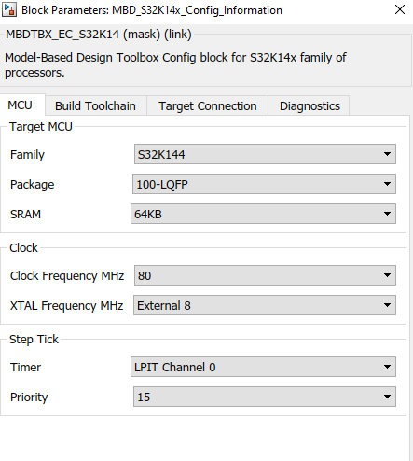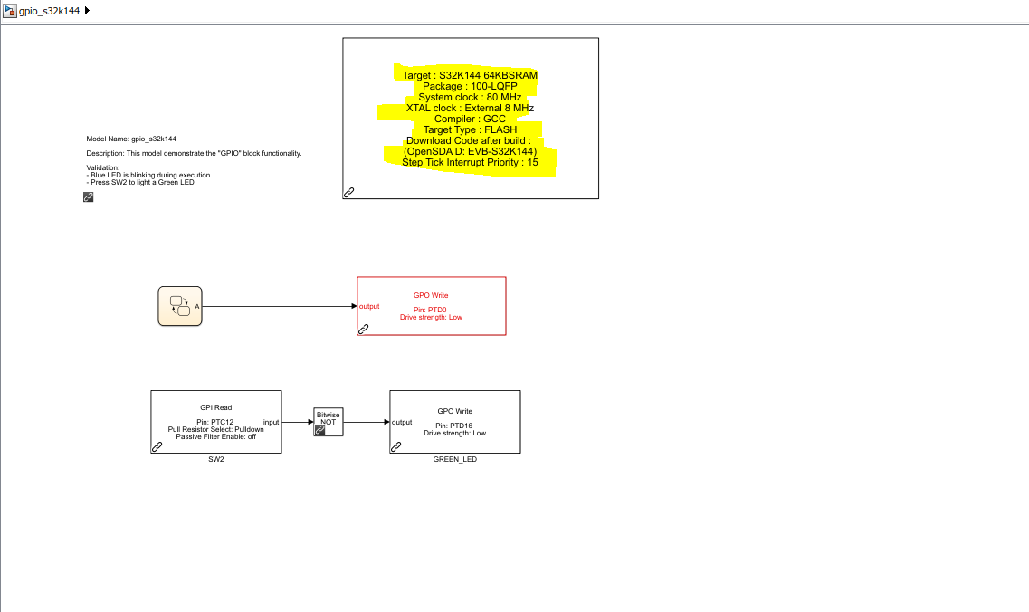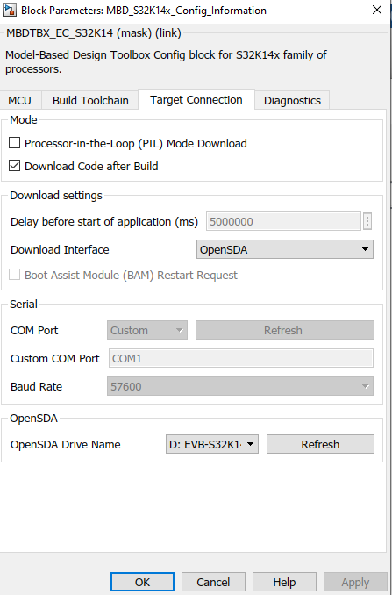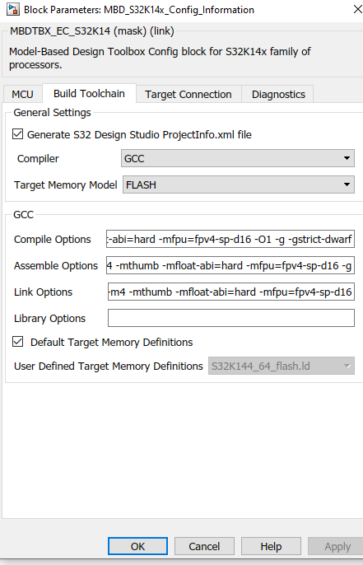

Connect your S32K144 EVB to the PC and Build the model using the Build Icon.



This will download the code to the board after the build.

UART Example

1. Open Matlab 2018b.
2. Open the mbd_s32k_examples.mdl from the previous sections.
3. In the Simulink model examples browser follow below steps.
4. Select **S32K14x Generic Simulink Models**.
5. Select **Communications**, then select **UART Hello World**.
6. This will load the UART hello world example.
7. Configure the model as highlighted in the below image, by double licking on the configuration block.

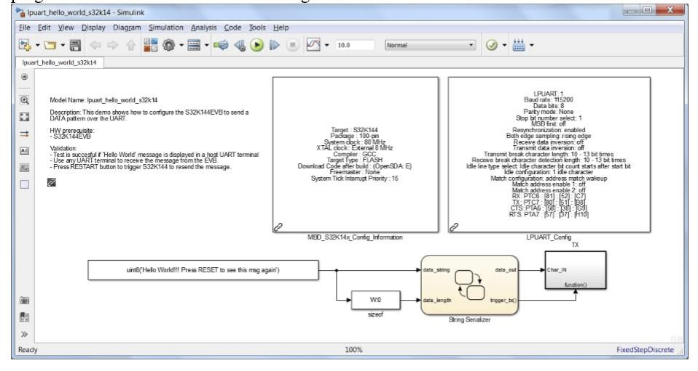

1. Configure the Target Configuration same as in the hello world example.
2. Configure LPUART Config as the following.

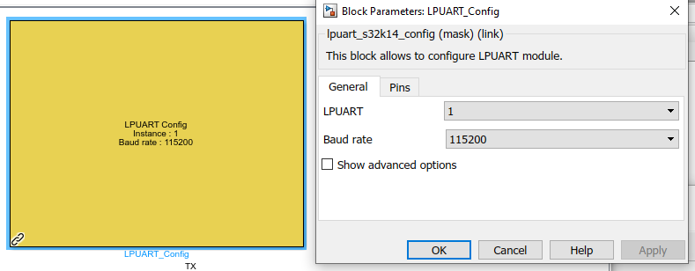

1. Build and download the code the S32K144 Board.
2. Open any UART terminal for the virtual COM port assigned and set up the   
   baud rate at 115200, data bits 8 and parity none. Putty or Tera-Term can be used.
3. Press the reset button on the evaluation board.
4. The S32K MCU sends “Hello World!!! Press RESET to see this msg again”   
   message over the UART and the UART terminal should display it.

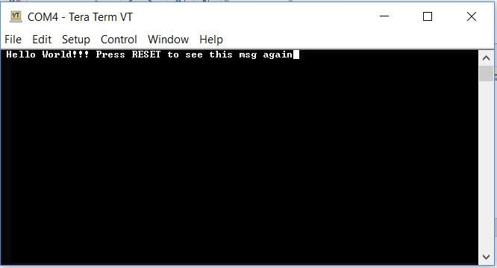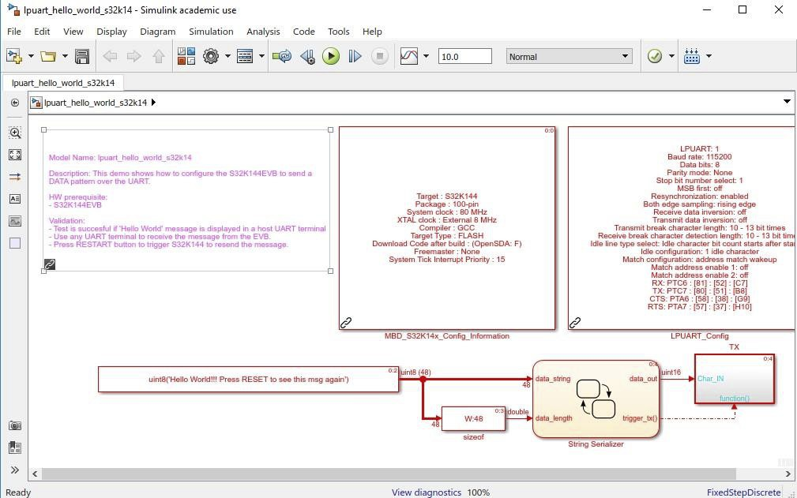

Note:

• Click on View diagnostics at the bottom of your project to find the name of the   
generated executable file, for example: “lpuart_hello_world_s32K14͘mot”

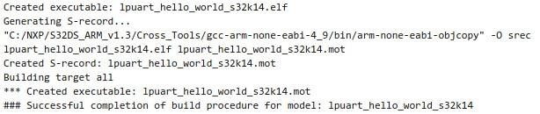

• Locate the “lpuart_hello_world_s32K14͘mot” at your directory͘

• You can copy and paste the file to your “EVB_S32K144” drive at any time to   
run your project.

Appendix A

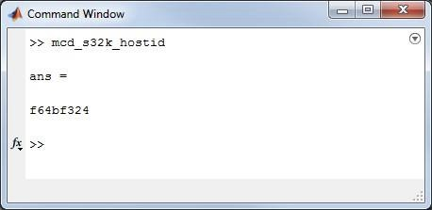

Locating the Host ID

If the Disk ID is used for the Host ID in the Model Based Design Toolbox software license, there are some different ways to obtain this:

A. From MATLAB Command

1. Open Matlab

2. In Command Window, enter “mbd_s32k_hostid”.

3. The hostid is the code returned.

In this example, Host ID is: f64bf324 (not case sensitive)

B. From DOS Command

1. Open CMD Prompt at {Model Based Design

Toolbox installation

folder}\mbdtbx_S32K\tools\mlt

2. In CMD Prompt window, enter “lmhostid -vsn”

3. Host ID is the value that follows DISK_SERIAL_NUM.

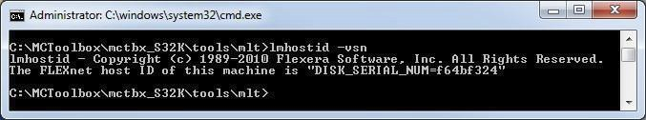

In this example, Host ID is: f64bf324 (not case sensitive)

Appendix B

